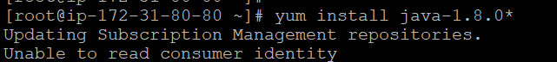

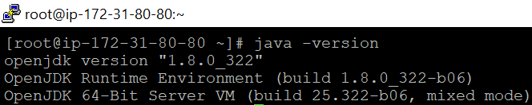

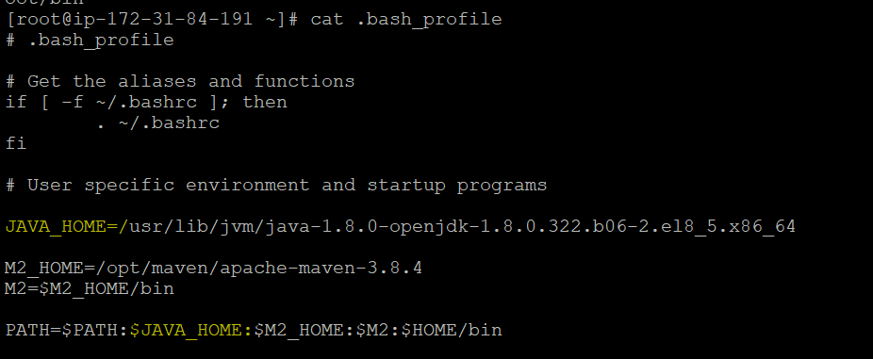



**wget -O /etc/yum.repos.d/jenkins.repo http://pkg.jenkins-ci.org/redhat/jenkins.repo**

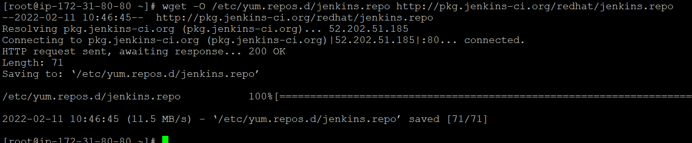

**# rpm --import http://pkg.jenkins-ci.org/redhat/jenkins-ci.org.key**



**# wget https://github.com/jenkinsci/jenkins/releases/download/jenkins-2.334/jenkins-2.334-1.1.noarch.rpm**

